Paper | SNR Calculation Method | Clean/Reconstructed data needed? | Comments
A Comparative Analysis of Methods for Evaluation of ECG Signal Quality after Compression | 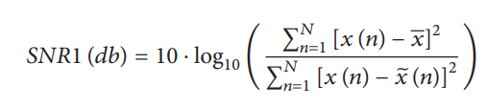  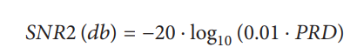  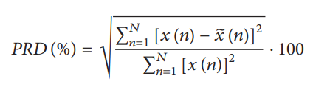 | Yes for both SNR calculations | There are also 3 normalised PRD equations mentioned in the paper.  PRD has three normalized versions (PRDN) [2, 5, 13, 15, 18–20, 24, 28, 35, 36, 41–43, 46, 47] that should be used if the signal has a nonzero DC component and/or an added offset where xbar is the mean of the original signal (the DC component) and P is the offset  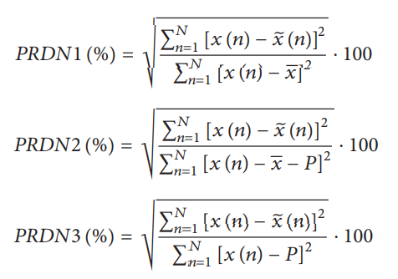
Electrocardiogram data compression using DCT based discrete orthogonal Stockwell transform | 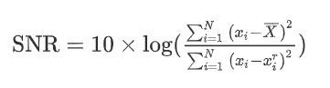 | Yes (xTi) | This is the same calculation as SNR1 in the above paper.
Denoising of ECG Signals Using Dual Tree Complex Wavelet Transform | 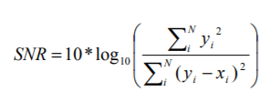  yi denoting the ECG signal after de-noising and xi is the clean ECG signal. | Yes | I’m not sure what the difference is between yi and xi
Analysis of Noise removal in ECG signal using Symlet wavelet | 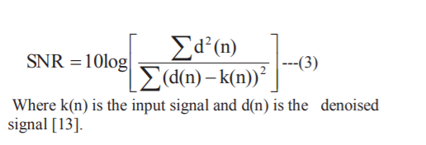 | Yes | Seems like this is the same equation as the one above
Quality Assessment of ICA Algorithms for ECG Signal Analysis | 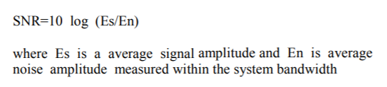 | Yes – the output signal is needed | 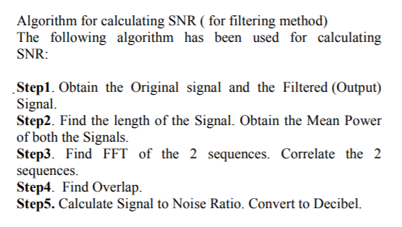
An adaptive filtering approach for electrocardiogram (ECG) signal noise reduction using neural networks | 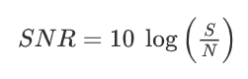  S is the power of the signal and N is the power of the noise.  “windowing” algorithm is employed where S is considered as a function of QRS amplitude and N is defined as a measurement of frequency-weighted noise power. To determine S, the peak-to-peak amplitude of the signal is measured with a 100 ms time window around each QRS-complex; then the mean of these measurements are used to obtain an estimate of signal power. | No | This method uses a windowing technique which I don’t think we can use for our data. To find S R peak identification is needed.
An Optimal Wavelet Approach for ECG Noise Cancellation | SNR is the ratio of amplitude of ECG signals before noise removal to the amplitude of noise removed through wavelet denoising. | yes | This paper looks at wavelet approaches to remove noise. Could this SNR approach be used with ICA (the mean amplitude of the noisy signals removed to be used)
ECG Signal De-noising using Discrete Wavelet Transform | 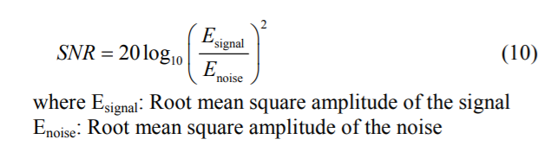  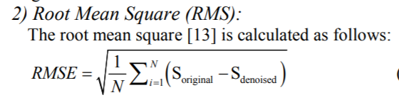 | Yes for the root mean squared formula
New Threshold and Shrinkage Function for ECG Signal Denoising Based on Wavelet Transforms | 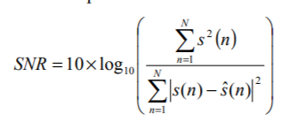  s (n) is the sampling value of simulative ECG signal at the nth point, sˆ(n) is the sampling value of denoised ECG signal at the same point. | Yes | Have seen this formula twice above
The optimal de-noising algorithm for ECG using stationary wavelet transform | 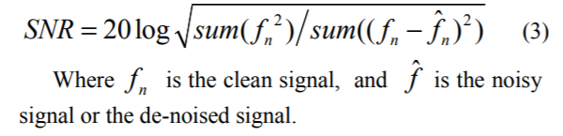 | Yes
ECG Signal De-noising using Discrete Wavelet Transform for removal of 50Hz PLI noise | 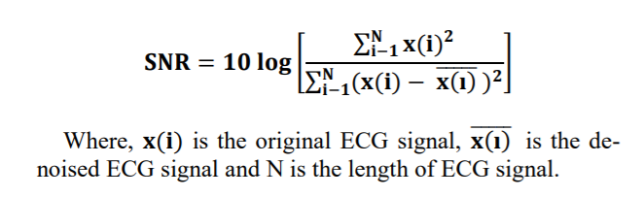 | Yes | Same formula as others
Assessment of Different Methods to Estimate Electrocardiogram Signal Quality | Karhunen-Loeve transform (KLT): KLT is a transformation that reduces a large set of variables down to a smaller set. The smaller set of variables separates the information of the different sources (ECG and Noise). In this way, noise can be estimated and the SNR calculated. | No | Not much in other papers about using KLT to compute the SNR.  This paper mentions different methods but doesn’t have a lot of information of the algorithms:  - LMS adaptive filtering  - LMS adaptive filtering was used to remove the ECG signal and therefore estimate the noise content. A template of the clean ECG signal was used as reference input signal to the adaptive filter. Then SNR can be estimated.
Non-Amplifying ECG Signal Acquisition System Based on A/D | The RMS (root mean square) voltage of ECG signal and noise is hard to acquire, because there is no standard ECG, different people has different ECG. In order to calculate SNR of non-amplifying ECG signal acquisition system approximately, a single frequency sine signal produced by a signal generator is sampled by the system. Then produce a standard sine signal of same frequency in MATLAB. The energy of sampled signal is maximum self-correlation (denote rxx) of it, which equals 1 after normalization, and the energy of standard sine signal is maximum cross-correlation (denote rxy) of standard signal and sampled signal, which value less than 1 after normalization. Then subtract rxy from rxx is the energy of noise.  10log(powersignal / powernoise) | no

